NAMA : LINA NURULLAILI

NIM : K3521039

**LABWORK 5**

1. **Latihan 1**

**Script HTML**

<!DOCTYPE html>

<html>

<head>

<title> Praktikum Z-index</title>

<style>

#layera{

position: absolute;

margin: 20px 150px;

height: 200px;

width: 200px;

background: yellow;

z-index: 2;

}

#layerb{

position: fixed;

margin: 100px 0;

height: 150px;

width: 300px;

background: lightblue;

z-index: 1;

}

#layerc{

position: fixed;

margin: 0 20px;

height: 200px;

width: 400px;

background: red;

z-index: 0;

}

</style>

</head>

<body>

<div id="layera">layer A</div>

<div id="layerb">layer B</div>

<div id="layerc">layer C</div>

</body>

</html>

**Hasil output**

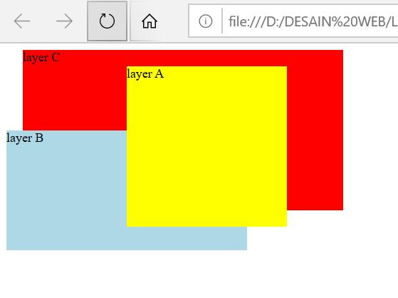

1. **Latihan 2**

**Script HTML**

<!DOCTYPE html>

<html>

<head>

<title>Sticky Navbar</title>

<link rel="stylesheet" type="text/css" href="style.css">

</head>

<body>

<div class="header">

<h3>Progam Studi Pendidikan Teknik Informatika dan Komputer UNS</h3>

</div>

<div class="menu">

<li><a href="#">HOME</a></li>

<li><a href="#">PROFILE</a></li>

<li><a href="#">ACADEMIC</a></li>

<li><a href="#">ABOUT</a></li>

<li><a href="#">PORTOFOLIO</a></li>

</div>

<div class="video-container">

<iframe src="https://www.youtube.com/embed/ijdrsNmd1YE?autoplay=1&mute=1" frameborder="0" allowfullscreen></iframe>

</div>

<div class="content">

<h2>Sticky Navigation Bar</h2>

<p>Lorem ipsum dolor sit amet, consectetur adipiscing elit, sed do eiusmod tempor incididunt ut labore et dolore magna aliqua. Tempus egestas sed sed risus pretium. Libero id faucibus nisl tincidunt eget nullam non nisiest. In iaculis nunc sed augue. Curabitur gravida arcu ac tortor dignissim convallis. Erat velit scelerisque in dictum non consectetur. Augue ut lectus arcu bibendum at varius vel pharetra. Ut placerat orci nulla pellentesque dignissim. Enim nunc faucibus a pellentesque sit. Dui vivamus arcu felis bibendum. Vulputate odio ut enim blandit volutpat maecenas volutpat.</p>

<p>Ac orci phasellus egestas tellus rutrum. Nullam eget felis eget nunc lobortis mattis aliquam faucibus. Semper feugiat nibh sed pulvinar proin gravida. Interdum consectetur libero id faucibus nisl tincidunt eget nullam. Aenean sed adipiscing diam donec adipiscing tristique risus nec feugiat. Volutpat odio facilisis mauris sit amet massa vitae. Sapien faucibus et molestie ac feugiat sed lectus vestibulum. Aliquet risus feugiat in ante metus. Adipiscing tristique risus nec feugiat in. At erat pellentesque adipiscing commodo elit at. Nibh nisl condimentum id venenatis. Neque volutpat ac tincidunt vitae semper. Faucibus et molestie ac feugiat sed lectus vestibulum mattis.</p>

</div>

</body>

</html>

**style.css**

body{

padding: 0px;

margin: 0px;

background: #e1e1e1;

}

.header{

background: rgba(0, 0, 0, 0.9);

padding: 6px 24px;

text-align: left;

color: white;

margin: 0px;

letter-spacing: 1px;

font: caption;

font-size: 24px;

text-transform: uppercase;

}

.video-container{

position: relative;

z-index: -1;

top: 0px;

}

.video-container iframe{

width: 100%;

height: 90vh;

}

.content{

padding: 0px 24px;

text-align: justify;

font-size: 20px;

}

.menu{

list-style-type: none;

margin: 0;

padding: 0;

overflow: hidden;

background-color: cadetblue;

position: -webkit-sticky; /* Safari */

position: sticky;

top: 0;

}

li {

float: left;

}

li a {

display: block;

color: white;

text-align: center;

padding: 14px 16px;

text-decoration: none;

}

li a:hover {

background-color: #111;

}

**Hasil output**

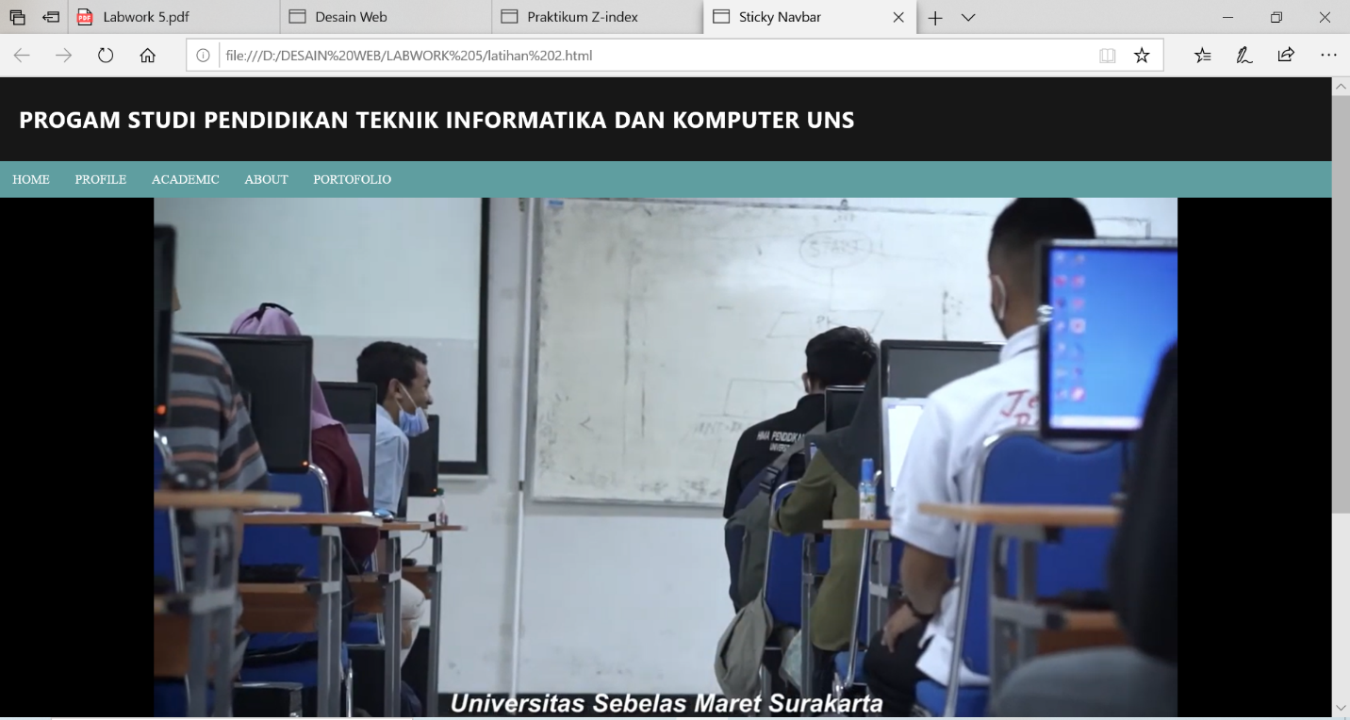

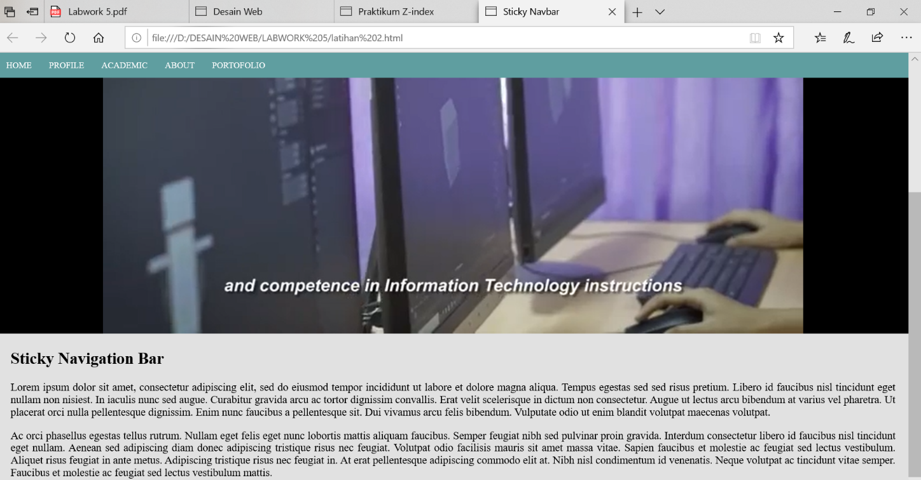

1. **Latihan 3**

**Script HTML**

<!DOCTYPE html>

<html>

<head>

<link rel="stylesheet" type="text/css" href="bahan.css">

<title>Desain Web</title>

</head>

<body>

<div id="wrap">

<div id="kiri">

<br><center>

<img src="images/logo.png">

</center><br>

<h2>Artikel Populer</h2>

<ul>

<li><a href="#">Desain Web</a></li>

<li><a href="#">HTML</a></li>

<li><a href="#">CSS</a></li>

<li><a href="#">Lain-lain</a></li>

</ul>

</div>

<div id="header">

<div id="judul">

<a href="#">Belajar Layout Website</a>

</div>

<div class="desc">

Menggunakan HTML dan CSS

</div>

</div>

<div id="menu">

<ul>

<li><a href="#">HOME</a></li>

<li><a href="#">TENTANG</a></li>

<li><a href="#">GALERI</a>

<ul>

<li><a href="#">VIDEO</a></li>

<li><a href="#">FOTO</a>

<ul>

<li><a href="#">PRIBADI</a></li>

<li><a href="#">UMUM</a></li>

</ul>

</li>

</ul>

</li>

<li><a href="#">KONTAK</a></li>

<li><a href="#">DAFTAR ISI</a></li>

<li><a href="#">BUKU TAMU</a></li>

</ul>

</div>

<div id="konten">

<div class="posttitle">Selamat Datang</div>

<div class="post">

<p>

Belajar Membuat Layout Desain Web menggunakan HTML dan CSS dengan mudah.

</p>

<p>

Untuk belajar HTML klik halaman <b><a href="#">HTML</a></b>

Dan untuk belajar CSS klik halaman <b><a href="#">CSS</a></b>

</p>

</div>

<div class="posttitle">Galeri</div>

<div class="post">

<img src="images/konten1.jpg">

<img src="images/konten2.jpg">

<img src="images/konten3.jpg">

</div>

</div>

<div id="footer">

&copy Copyright 2020. All Right Reserved <br> Prodi Pendidikan Teknik Informatika dan Komputer <br> Universitas Sebelas Maret

</div>

</div>

</body>

</html>

**style.css**

#wrap{

width: 1000px;

height: 800px;

margin: 0 auto;

background-color: white;

}

#header{

background-image: url(images/header.jpeg);

border-bottom-right-radius: 50px;

width: 730px;

height: 300px;

margin: auto;

box-shadow: 0 0 10px rgba(0, 0, 0, .25);

float: right;

}

#judul{

font-size: 50px;

text-align: right;

padding: 200px 40px 0 0;

}

#judul a{

color: white;

text-decoration: none;

}

#judul a:hover{

color: grey;

}

.desc{

font-size: 30px;

color: white;

text-align: right;

padding: 0 40px 0 0;

}

#menu ul{

float: right;

background: darkblue;

padding: 0 0px;

position: relative;

box-shadow: 0 0 10px rgba(0, 0, 0, .25);

list-style: none;

width: 730px;

}

#menu ul:after{

content: "";

clear: both;

display: block;

}

#menu ul li{

float: left;

}

#menu ul li:hover{

background: blue;

}

#menu ul li a{

display: block;

color: white;

padding: 10px 20px;

text-decoration: none;

}

#menu ul li:hover a{

color: white;

}

#menu ul li:hover > ul{

display: block;

}

#menu ul ul{

background: darkblue;

position: absolute;

padding: 0;

top: 100%;

display: none;

width: auto;

}

#menu ul ul li{

float: none;

position: relative;

}

#menu ul ul li a{

padding: 10px 30px;

color: white;

}

#menu ul ul li a:hover{

background: blue;

color: white;

}

#menu ul ul ul{

position: absolute;

left: 100%;

top: 0;

}

#kiri{

border-top-left-radius: 50px;

background-color: white;

width: 250px;

height: auto;

margin: 0 0 20px;

float: left;

list-style: none;

box-shadow: 0 0 10px rgba(0, 0, 0, .25);

}

#kiri ul{

margin: 0 0 20px 20px;

padding: 0;

list-style: none;

width: 200px;

}

#kiri li{

width: 100%;

margin: 0;

padding: 0;

list-style: none;

}

#kiri h2{

margin: 0px 0 0px 0;

padding: 5px 12px;

color: white;

font-size: 20px;

background: darkblue;

}

#kiri a{

display: block;

padding: 3px 10px;

text-decoration: none;

color: black;

border-bottom: 1px dotted blue;

}

#kiri a:hover{

background: blue;

color: white;

}

#konten{

background-color: white;

width: 690px;

height: auto;

margin: 0 0 20px;

padding: 20px 20px 20px 20px;

float: right;

box-shadow: 0 0 10px rgba(0, 0, 0, .25);

}

.posttitle{

text-decoration: none;

font-size: 30px;

font-family: Arial;

color: blue;

}

.posttitle a{

text-decoration: none;

}

.post{

margin: 0 20px 0 20px;

text-align: justify;

}

b a{

color: blue;

text-decoration: none;

}

img{

width: 30%;

}

#kiri img{

width: 200px;

height: 200px;

}

#footer{

background-color: darkblue;

padding: 20px 0 0 0;

width: 1000px;

height: 90px;

clear: both;

margin: 20 0;

text-align: center;

color: white;

border-top-left-radius: 50px;

border-bottom-right-radius: 50px;

}

**Hasil output**

